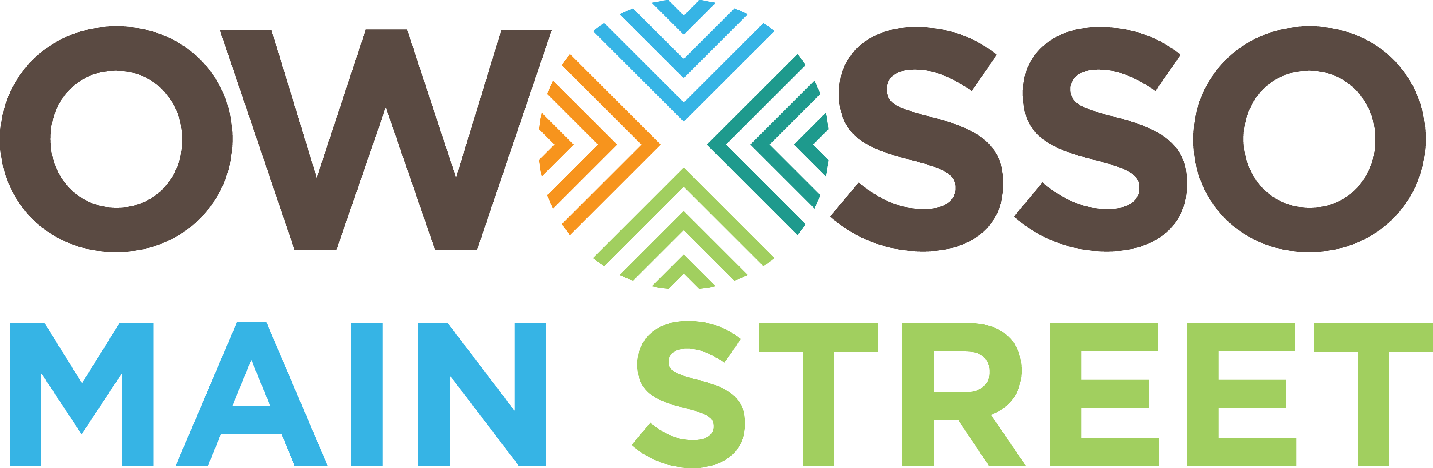
Owosso Main Street/DDA
Strategic Planning Report

Program Structure
OMS is a volunteer-driven organization. While there is a paid employee in the form of an Executive Director, this employee is there to help guide the efforts of the board and program volunteers.

To give the committees direction, the OMS Board of Directors sets goals and objectives allowing each committee to work towards those goals through the lens of their committee's skill set. Under each goal, committees create specific projects to help achieve their objectives. These projects should have specific tasks, goals and a means to measure success.

Once projects are determined by committee members under board goals and objectives, it is up to the committees to create a work plan for each project. Work plans should include all steps necessary to complete the plan, including a start and finish time for each task, as well as a budget, and the person assigned to complete each task. One person should act as the chair for each project, taking the lead to make sure that the work plan is completed. Individual volunteers should be assigned to complete the individual tasks.

Once a work plan is completed, it is compiled with the other proposed project work plans to help determine an overall program budget. It is up to the board to either approve or deny a project and work plan, based on how the proposed project is slated to meet the board’s objectives and how the work plan is laid out. Once a project is approved, the committee has the authority to carry out the tasks and complete the project without board interference.

Mission Statement
The board reviewed the mission statement developed for the organization during the 2015/2016 board retreat:

“Owosso Main Street’s mission is to foster an active and thriving downtown that is the heart of our community by promoting historic preservation and drawing both local residents and visitors to our city.”

The board agreed that this mission statement still fits the values of the organization and will remain for the 2021/2022 year.

Vision Statement
The board reviewed the vision statement developed for the organization during the 2015/2016 board retreat:

“Our downtown, bright with promise and potential, captures the spirit of community. It is a gathering place to work, eat, play, and stay. Downtown Owosso is rich with opportunities in art, entertainment, business, and learning. Owosso Main Street unites individuals, businesses, and local government to revitalize our historic downtown. It is a comprehensive approach that focuses on community assets and partnerships to preserve and promote historic Owosso.”

The board agreed that this vision statement still fits the path the organization is planning, and will remain for the 2020/2021 year.

Transformation Strategies
In 2017, OMS worked with the National and Michigan Main Street Centers to develop new transformation strategies for our downtown. Using market data, community input, and reviewing all our community assets, the board of directors approved two transformation strategies for the downtown. They are as follows:
- Day Trip Destination
- Increase Upper-Floor Residential Development/Density

***For a deeper dive into OMS’ Transformation Strategy Development please review the National Main Street Center’s powerpoint presentation and OMS’ Transformation Strategy write-up.***

Tagline
During our 2018 Rebranding Services provided by the Michigan Main Street Center and the MEDC, OMS received and new brand logo, brand strategy, brand statement, and community tagline. The new Downtown Owosso tagline is: “Gather Around”

***For all rebranding information please review the Rebranding Report and/or YouTube presentation provided by Arnett-Muldrow.***

Board of Directors Self-Assessment
The Board determined that two board-level initiatives should continue over the next year. They are as follows:

- Develop a comprehensive volunteer recruitment & retention strategy that increases the capacity of the overall program; and
- Develop a fund generation structure/program (in addition to DDA & TIF funding) that secures adequate financial resources for building program capacity.

The board agreed to form new sub-committees around this effort to ensure completion of these initiatives.

2021/22 Goals & Objectives
Due to COVID-19 many of the Goals & Objectives established by the Board of Directors in December 2019 were never implemented. As a result, the decision was made to keep & continue (with slight modifications) the 2020/2021 Goals & Objectives into the 2021/2022 fiscal year. Each goal and objective are located in the table below:

2021-2022 Goals & Objectives

Goal # 1:

Cultivate an environment that demonstrates a commitment to the development of businesses, housing and community organizations in Downtown Owosso.

Objectives:
- Increase the # of residential units in the pipeline for development. - Use current programming resources (local, private, & public) to better assist property owners in preparing properties for residential development.
- Increase the # touchpoints with perspective and existing property owners. - Develop a pipeline for perspective business owners using entrepreneurial ecosystems best practices. Develop better training and communication tools to aid existing downtown businesses.
- Increase in approved façade grant applications. - Work with the MEDC and local property owners to start a new round of CDGB facade grants.
- Increase in Main Street volunteerism throughout stakeholders.
- Active, collaborative involvement between Owosso Main Street/DDA and City in moving the Redevelopment Ready Communities initiative forward (including the City’s Master Plan).
- Evidence of improved internal communication between Owosso Main Street/DDA, district non-profits, and City Departments.

Goal # 2:
Create and demonstrate a welcoming culture of hospitality for the visitors, businesses, and residents of Downtown Owosso

Objectives:
- Create a training and educational network to support small businesses. - Using entrepreneurial ecosystems best practices and our program’s relationship with the SBDC, develop/find better educational tools to aid small businesses.
- Increase event-driven gross sales for small business with the district. - Work with committee programming and business owners to ensure programming & events translate to larger sale numbers for downtown businesses.
- Develop a Downtown Hospitality training/structure for businesses within the district.
- Increase in online digital outreach and connections. - Continue to build out downtownowosso.org to include greater tourism elements and include all state required reporting criteria. In addition, increase the number of businesses participating in the online store option.
- Increase in development activity and historic preservation within the district.
- Increase streetscape improvements within the district.
- Create a program that promotes the occupation of vacant spaces.

Goal # 3:
Expand and sustain a model of “coopetition” among Downtown Owosso businesses, organizations and attractions.

Objectives:
- Help promote cross-business referrals and events within the district.
- Maintain/increase collaborative, promotional strategies
- Create new networking events for businesses within the district. Maintain monthly business owner’s meetings.
- Work to expand coopetition to the boundaries of the district.
- Create coopetition and best practice educational opportunities.
- Improve communication between Main Street, City Depts. and other community organizations

